**BLINKING OF LED USING 8051 MICROCONTROLLER USING PROTEUS**

**AIM:**

To Write an assembly language program to LED blink using 8051

**SOFTWARES REQUIRED:**

* Proteus software

**PROGRAM**

ORG 0000H

UP: SETB P2.0

ACALL DELAY

CLR P2.0

ACALL DELAY

SJMP UP

DELAY: MOV R4,#35

H1:MOV R3,#255

H2:DJNZ R3,H2

DJNZ R4,H1

RET

END

**CIRCUIT DIAGRAM:**

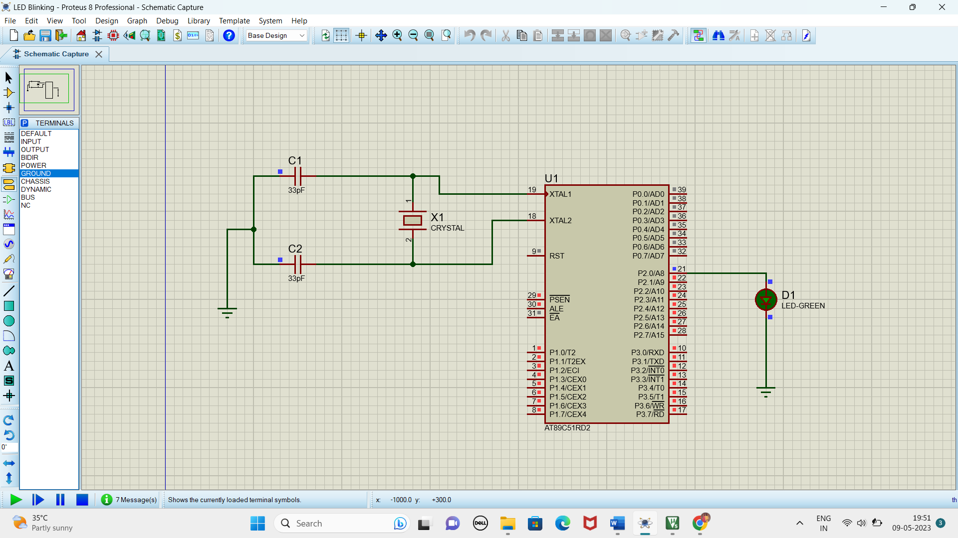

**RESULT**

Thus the program has been successfully verified and executed.

**LED TOGGLE USING 8051 USING PROTEUS**

**AIM:**

Write an assembly language program for LED Toggle Using 8051 using Keil and Proteus

**SOFTWARE REQUIRED:**

* Proteus 8 software.

**PROGRAM:**

ORG 0000H

UP: MOV P2,#55H

ACALL DELAY

MOV P2,#0AAH

ACALL DELAY

SJMP UP

DELAY:MOV R4,#10

H1:MOV R3,#255

H2:DJNZ R3,H2

DJNZ R4,H1

RET

END

**CIRCUIT DIAGRAM:**

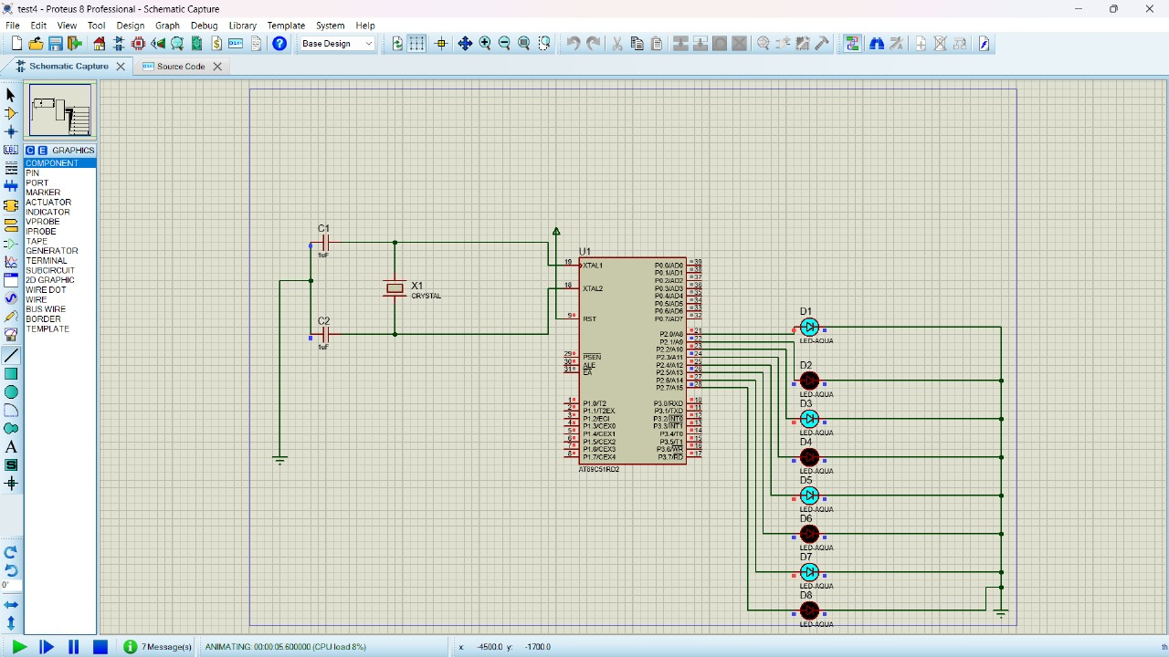

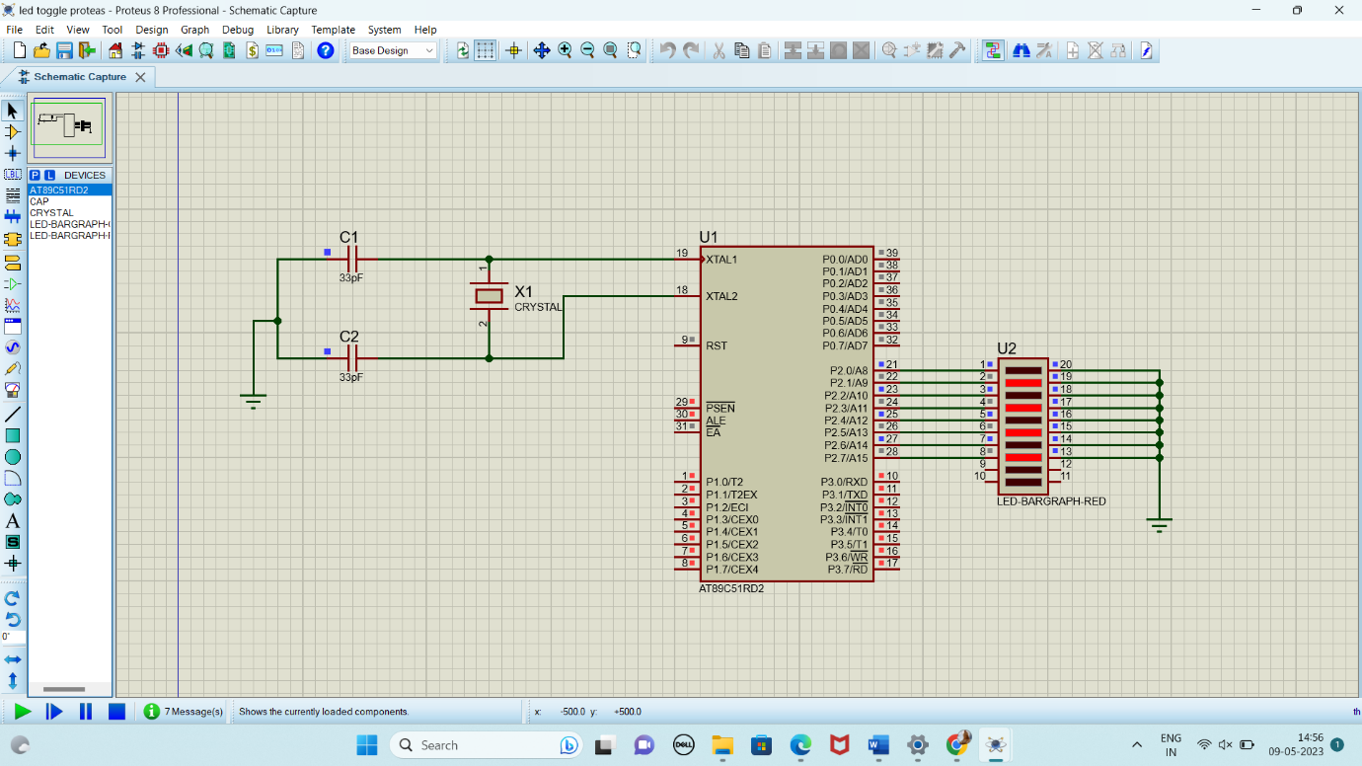

**RESULT:**

Thus the program has been successfully verified and executed.

**LED CHASER USING 8051 USING PROTEUS**

**AIM:**

Write an assembly language program for LED Chaser Using 8051 using Keil and Proteus

**SOFTWARE REQUIRED:**

* Proteus 8 software.

**PROGRAM:**

ORG 0000H

UP: MOV P2,#01H

ACALL DELAY

MOV P2,#02H

ACALL DELAY

MOV P2,#04H

ACALL DELAY

MOV P2,#08H

ACALL DELAY

MOV P2,#10H

ACALL DELAY

MOV P2,#20H

ACALL DELAY

MOV P2,#40H

ACALL DELAY

MOV P2,#80H

ACALL DELAY

SJMP UP

DELAY: MOV R4,#255

H1: DJNZ R4,H1

RET

END

**CIRCUIT DIAGRAM:**

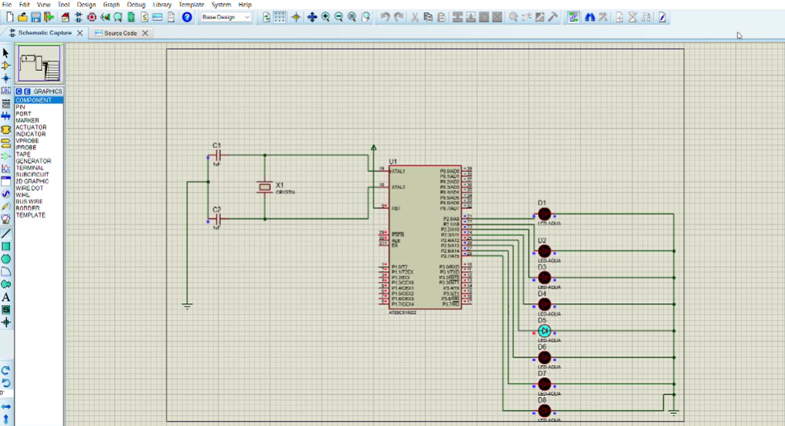

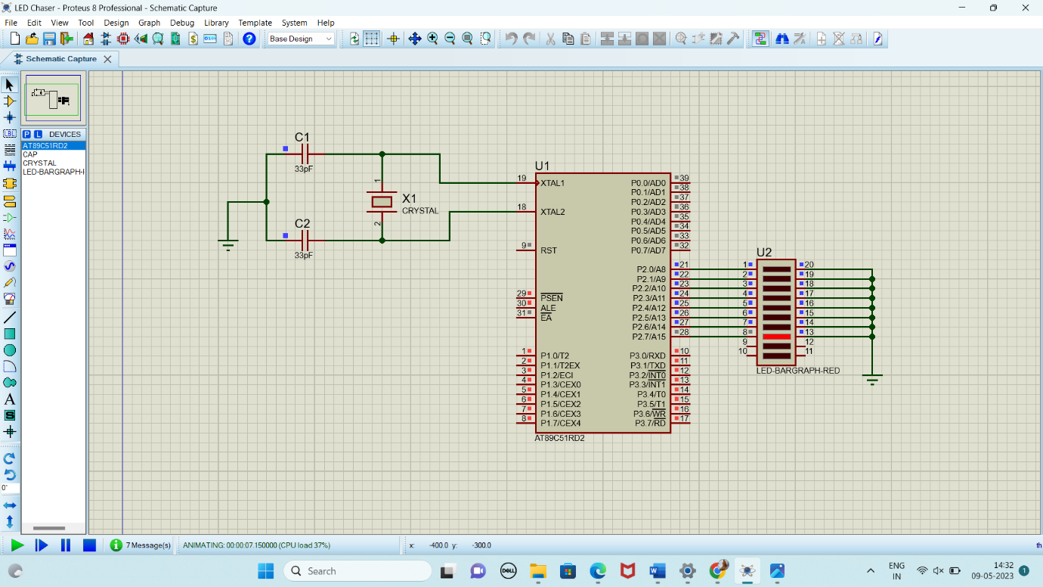

**RESULT:**

Thus the program has been successfully verified and executed.